PRACTICAL NO: 1
1. Configure Routers:
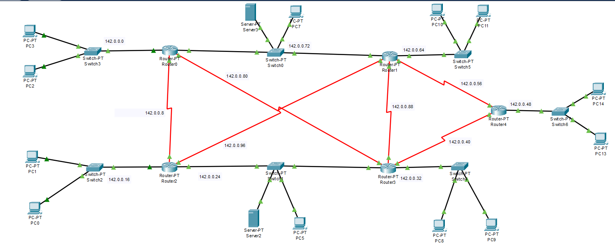
Diagram:-

Addressing Table:-
Device | Interface | IP Address | Subnet Mask | Default Gateway | Switch Port
Router0 | Fa0/0 | 142.0.0.76 | 255.255.255.248 | N/A | N/A
Router0 | Fa1/0 | 142.0.0.1 | 255.255.255.248 | N/A | N/A
Router0 | Serial2/0 | 142.0.0.9 | 255.255.255.248 | N/A | N/A
Router0 | Serial3/0 | 142.0.0.81 | 255.255.255.248 | N/A | N/A
Router1 | Fa0/0 | 142.0.0.73 | 255.255.255.248 | N/A | N/A
Router1 | Fa1/0 | 142.0.0.65 | 255.255.255.248 | N/A | N/A
Router1 | Serial2/0 | 142.0.0.90 | 255.255.255.248 | N/A | N/A
Router1 | Serial3/0 | 142.0.0.58 | 255.255.255.248 | N/A | N/A
Router1 | Serial6/0 | 142.0.0.97 | 255.255.255.248 | N/A | N/A
Router2 | Fa0/0 | 142.0.0.25 | 255.255.255.248 | N/A | N/A
Router2 | Fa1/0 | 142.0.0.17 | 255.255.255.248 | N/A | N/A
Router2 | Serial2/0 | 142.0.0.10 | 255.255.255.248 | N/A | N/A
Router2 | Serial3/0 | 142.0.0.98 | 255.255.255.248 | N/A | N/A
Router3 | Fa0/0 | 142.0.0.28 | 255.255.255.248 | N/A | N/A
Router3 | Fa1/0 | 142.0.0.33 | 255.255.255.248 | N/A | N/A
Router3 | Serial2/0 | 142.0.0.89 | 255.255.255.248 | N/A | N/A
Router3 | Serial3/0 | 142.0.0.41 | 255.255.255.248 | N/A | N/A
Router3 | Serial6/0 | 142.0.0.82 | 255.255.255.248 | N/A | N/A
Router4 | Fa0/0 | 142.0.0.49 | 255.255.255.248 | N/A | N/A
Router4 | Serial2/0 | 142.0.0.57 | 255.255.255.248 | N/A | N/A
Router4 | Serial3/0 | 142.0.0.42 | 255.255.255.248 | N/A | N/A
PC2 | Fa0 | 142.0.0.3 | 255.255.255.248 | 142.0.0.1 | Switch3
PC3 | Fa0 | 142.0.0.2 | 255.255.255.248 | 142.0.0.1 | Switch3
PC1 | Fa0 | 142.0.0.18 | 255.255.255.248 | 142.0.0.17 | Switch2
PC0 | Fa0 | 142.0.0.19 | 255.255.255.248 | 142.0.0.17 | Switch2
Server2 | Fa0 | 142.0.0.26 | 255.255.255.248 | 142.0.0.25 | Switch1
PC5 | Fa0 | 142.0.0.27 | 255.255.255.248 | 142.0.0.25 | Switch1
PC8 | Fa0 | 142.0.0.34 | 255.255.255.248 | 142.0.0.33 | Switch4
PC9 | Fa0 | 142.0.0.35 | 255.255.255.248 | 142.0.0.33 | Switch4
PC13 | Fa0 | 142.0.0.50 | 255.255.255.248 | 142.0.0.49 | Switch6
PC14 | Fa0 | 142.0.0.51 | 255.255.255.248 | 142.0.0.49 | Switch6
PC10 | Fa0 | 142.0.0.67 | 255.255.255.248 | 142.0.0.65 | Switch5
PC11 | Fa0 | 142.0.0.66 | 255.255.255.248 | 142.0.0.65 | Switch5
PC7 | Fa0 | 142.0.0.74 | 255.255.255.248 | 142.0.0.73 | Switch0
Server3 | Fa0 | 142.0.0.75 | 255.255.255.248 | 142.0.0.73 | Switch0

Assigning IP to the router (CLI):-
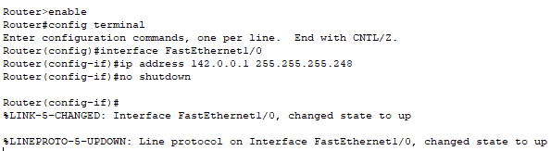

Assigning ospf to the router:-
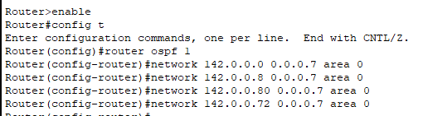
Same way assign to all router’s connected networks to the in ospf.
Now checking the established connection:-
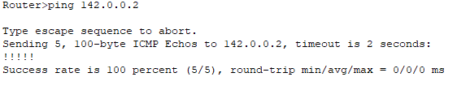

Checking IP route:-
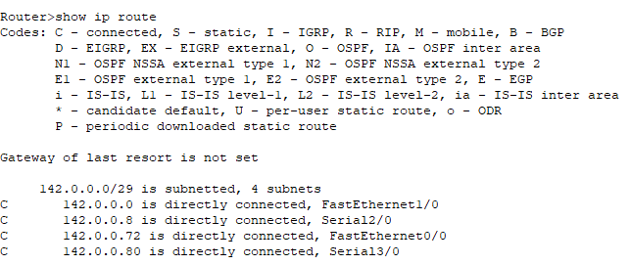
a. OSPF MD5 authentication.
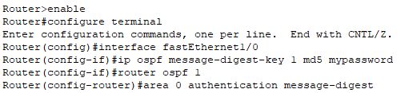

Assigning these to all interfaces of each router.
All routers in the same OSPF link must use:
- Same key number
- Same password
- MD5 enabled on both ends
Checking whether the md5 authentication is applied or not:-
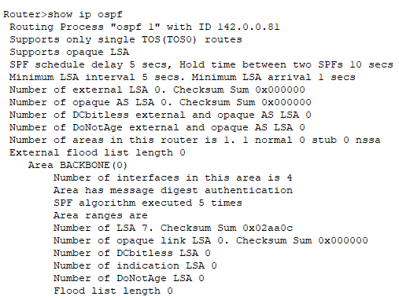
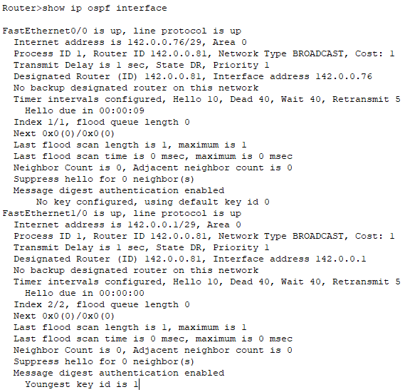
We can confirm it by checking below output where key id is defined and authentication is enabled.

b. NTP.
Here we defined a ntp server which will provide times to other routers and add it to any network and also assign default gateway as well .
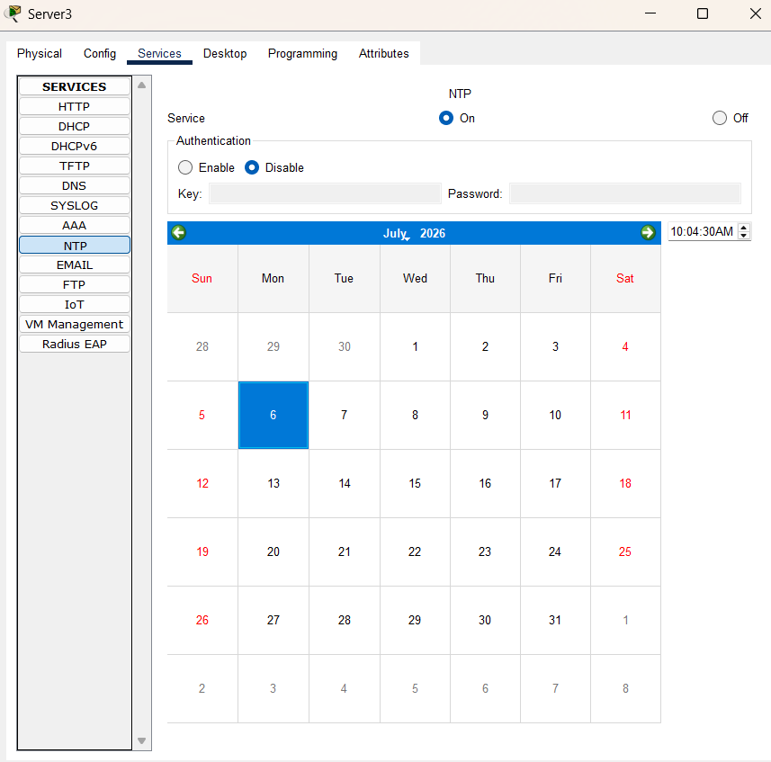
Now set ntp server as a date provider for routers.
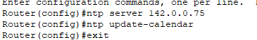
Now assign each router with ntp server.
Then checking time on routers.
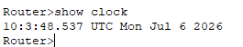
c. to log messages to the syslog server.
First enable syslog server as below:
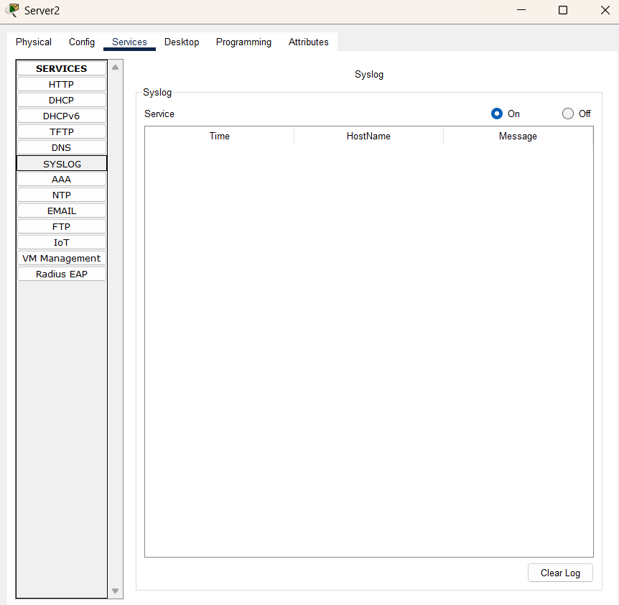

Now we will assign syslog server ip to the router to maintain logs
As below:-
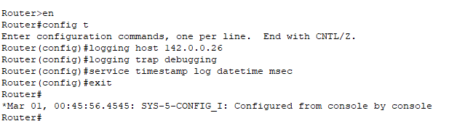

We can also check on syslog server logs to check logs.
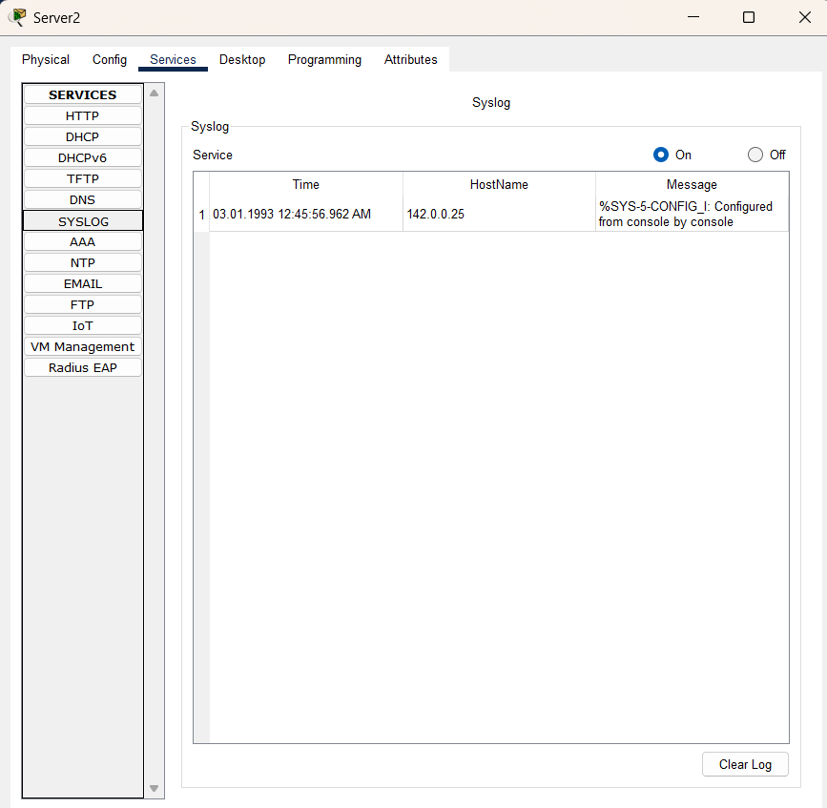
Accessing router through Telnet:-
First you have to configure router:-
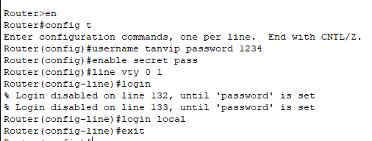
It will allow us to access any user of router through cli using login local Otherwise normal user access will be granted.
Now from pc we will try to access router.
